Build a Neural Network model for 50_startups data to predict profit

**Ans :**

**R Code :**

## Neural Network

########## 50 Startups Data Set #########

startups <- read.csv('D:\\Data Science\\Excelr\\Assignments\\Assignment\\Neural Networks\\50_Startups_r.csv')

# custom normalization function

normalize <- function(x) {

return((x - min(x)) / (max(x) - min(x)))

}

# apply normalization to entire data frame

startups_norm <- as.data.frame(lapply(startups[2:5], normalize))

# create training and test data

startups_train <- startups_norm[1:35, ]

startups_test <- startups_norm[36:50, ]

## Training a model on the data ----

# train the neuralnet model

library(neuralnet)

# simple ANN with only a single hidden neuron

startups_model <- neuralnet(formula = Profit ~ R.D.Spend + Administration +

Marketing.Spend ,

data = startups_train)

# visualize the network topology

windows()

plot(startups_model)

## Evaluating model performance ----

# obtain model results

model_results <- compute(startups_model, startups_test)

# obtain predicted strength values

predicted_profit <- model_results$net.result

# examine the correlation between predicted and actual values

cor(predicted_profit, startups_test$strength)

## Improving model performance ----

# a more complex neural network topology with 5 hidden neurons

startups_model2 <- neuralnet(Profit ~ R.D.Spend + Administration +

Marketing.Spend ,

data = startups_train, hidden =c(5,2))

# plot the network

windows()

plot(startups_model2)

# evaluate the results as we did before

model_results2 <- compute(startups_model2, startups_test)

predicted_profit2 <- model_results2$net.result

cor(predicted_profit2, startups_test$Profit)

**Results :**

> cor(predicted_profit, startups_test$strength)

[,1]

[1,] 1

> cor(predicted_profit2, startups_test$Profit)

[,1]

[1,] 0.7857518

**Plots :**

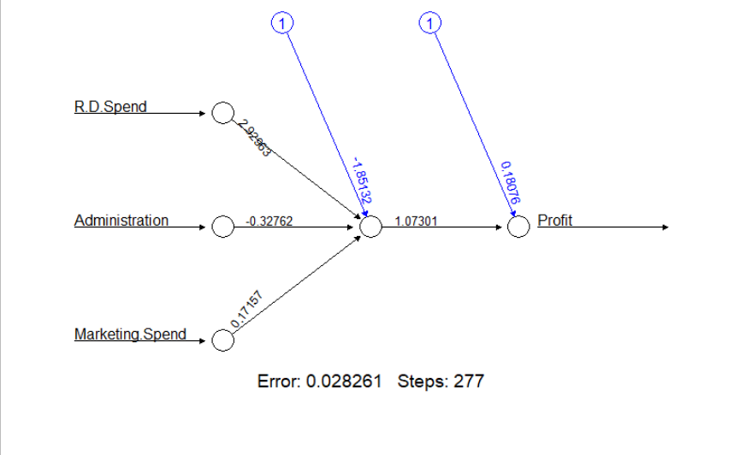

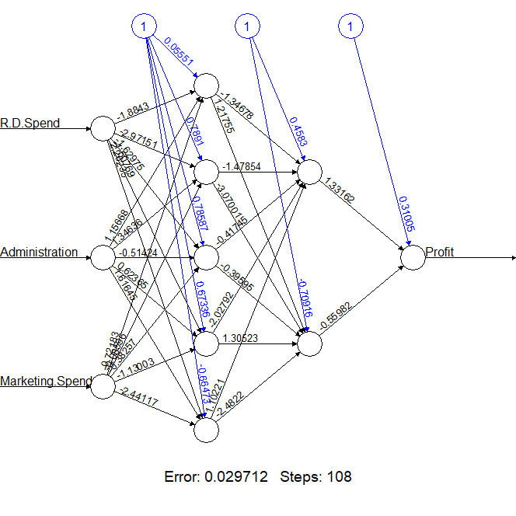

**Inference :**

Getting more accuracy without the extra hidden layers. So the normal model is sufficient.